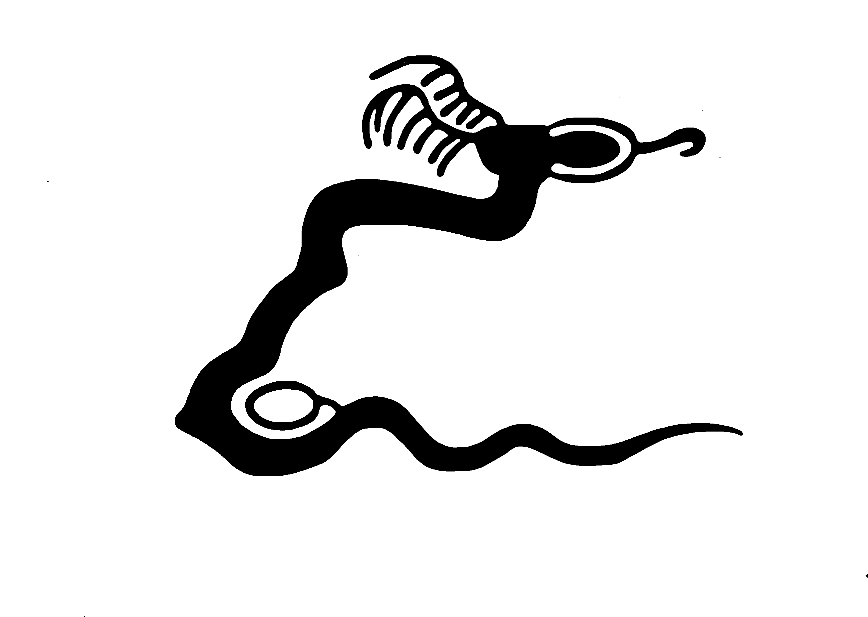
Nine Mile Canyon Coalition
P.O. Box 402
Price, Utah 84501

Nine Mile Canyon Coalition
Comments of Uinta Basin Railway Draft EIS
27 January 2021

The Nine Mile Canyon Coalition is a not for profit corporation dedicated to:
- the preservation and protection of Nine Mile Canyon;
- the education of the public on issues relating to Nine Mile Canyon;
- the provision of assistance to coordinate Nine Mile Canyon interests;
- the promotion of programs of scientific research in Nine Mile Canyon.
Actions proposed in the EIS have direct, indirect and cumulative effects on the natural, cultural and social environments within the Canyon and will affect our members and associates, including land owners, ranchers, professional archaeologists and people who enjoy outdoor recreation in Nine Mile Canyon. The Coalition offers the following comments on the Uinta Basin Railway Draft EIS.
Section 2.1 Purpose and Need
The Purpose and Need section is unduly constrained and limiting the alternatives. It is clear the real purpose of this project is to ship crude oil out of the Uinta Basin, not to build a railroad for the sake of building a railroad. Over the years we have seen many different proposals for moving crude oil out of the Uinta Basin. These have included:
- Improvement of US Hwy. 40 to better accommodate truck traffic.
- Improvement of US Hwy 191 over Indian Canyon to facilitate trucking.
- Refining the product within the Uinta Basin so only finished products are shipped.
- Construction of the Book Cliffs road to I-70.
- Various pipeline proposals to the Wasatch Front, Carbon County and I-70, with heated pipelines, and partial refining in the Basin to lower the flow point temperature.

Several of these have been proposed by the Seven County Infrastructure Coalition or individual member counties. We have attended numerous presentations on these various proposals and been lobbied to support them. All of these proposals were lower cost than the proposed railroad. This EIS should be the opportunity to determine the optimal solution to the problem of shipping more crude oil from the Uinta Basin.

All of these would seem to be reasonable alternatives for consideration in this EIS. There are multiple ways to move crude oil from the Basin yet this EIS’ strict focus is only on a railroad. This seems to be bucking a trend. Nationwide there are over a hundred thousand miles of abandoned or inactive railroad. Carbon and Emery County have an abundance of abandoned miles of track and railheads. It appears the mere presence of a railroad does not guarantee community prosperity. Trucking, piping and refining may be outside the jurisdiction of the Surface Transportation Board, but under NEPA the Board has the ability and obligation to consider reasonable alternatives outside of agency authority.
There is a glaring failure to make a business case for this railroad. It appears to be taking the approach of “if we build it, they will come.” There is no analysis of the costs and returns associated with the railroad. How would shipping cost of a barrel of oil on the railroad compare with producers’ shipping costs of the existing trucking? Will the railroad cash flow and provide a return on investment? How much volume would need to be shipped and at what cost for the railroad to break even? How does the market price of a barrel of Uinta Basin crude oil affect the viability of the railroad? Is there a commitment from the Uinta Basin oil producers to ship exclusively by rail if it is constructed?
The need for the railroad is predicated on massive expansion of drilling and production of waxy crude in the Uinta Basin. The EIS at 2.4.1 projects shipping 130,000 to 350,000 barrels per day. In 2016, the Basin produced 66,000 barrels per day and has never produced anything close to 130,000 barrels in a day.
Given current economics in the oil business with record numbers of bankruptcy, lack of cash flow, high debt, and investors fleeing the oil and gas sector generally, is a massive expansion of production a realistic expectation? The lack of interest in BLM oil and gas lease sales indicates the industry does not have optimistic outlook. Even with an economically healthy oil industry, it is likely other limiting factors in the Uinta Basin such as air quality, volume of produced water, could prevent even the minimum projected production and daily shipping from being reached. The Uinta Basin is already in non-attainment status for air quality, primarily due to oil and gas extraction. It is hard to imagine tripling the production of oil and meeting Clean Air Act standards.
2.1 Proposed Action
“The total volume of rail traffic would depend on future markets for crude oil, which is driven by global demand and capacity at oil refineries. Depending on those future market conditions, the Coalition estimates that as few as 3.68 or as many as 10.52 trains could operate on the proposed rail line each day, on average. ²….Footnote quote: ² In its petition, the Coalition has stated that projections of future rail traffic are based on conditions existing before the ongoing COVID-19 pandemic, and that it anticipates these conditions caused by the pandemic will be temporary in nature.”
The current crude-oil context combines supply shock with an unprecedented demand drop situated within a larger global humanitarian crisis. The sector’s financial and structural health at the close of the pandemic is worse now than in previous crises. The advent of shale, excessive supply, and generous financial markets that overlooked the limited capital discipline have all contributed to poor returns. Today, with prices touching 30-year lows, and accelerating societal pressure, change is inevitable. The COVID-19 crisis accelerates what was already shaping up to be one of the industry’s most transformative moments. this is based on pre-COVID conditions. A post-COVID market and cost-analysis to revisit these predications is necessary to confirm that this effort is worth the long-term and permanent change to our finite natural and cultural resources in the Basin.
Given current economics in the oil business with record numbers of bankruptcy, lack of cash flow, high debt, and investors fleeing the oil and gas sector generally, is a massive expansion of production a realistic expectation? The lack of interest in BLM oil and gas lease sales indicates the industry does not have optimistic outlook. Even with an economically healthy oil industry, it is likely other limiting factors in the Uinta Basin such as air quality, volume of produced water, could prevent even the minimum projected production and daily shipping from being reached. The Uinta Basin is already in non-attainment status for air quality, primarily due to oil and gas extraction. It is hard to imagine tripling the production of oil and meeting Clean Air Act standards.
Section 2.2 Alternatives
Please see our comments on Purpose and Need above, for comments on the scope of the alternatives.
Section 2.2.3
We note that most of the Coalition’s applicant committed mitigation measures are mostly a recitation of regulatory requirements and standard operating procedures. These should be taken for granted, incorporated into the action alternatives and not be presented as though they are there to mitigate impacts beyond that already required. We also question the value of mitigation to cultural resources as a result from a yet to be developed Programmatic Agreement. Mitigation of impacts should be measurable and effective. Without a signed, completed PA, it is impossible to assess the effectiveness of the mitigation. We strongly recommend and request a supplemental Draft EIS be issued upon completion of the PA and proper analysis of actual impacts and residual impacts to cultural resources.
2.3.7 Bridges, Culverts, and Stream Realignments

We see drainage modifications as being a major change agent in this EIS. The drainages of Nine Mile Canyon experience flash floods and/or debris flows almost yearly. Some years it is only one side canyon, some years several. Our experience is culverts in this region experience high rates of failure. The alternatives should anticipate and describe a rate of yearly culvert failure and include that in impact analysis.

Chapter 3 General Comments

There does not appear to be a commitment to monitor the short term and long term impacts of this project. Instead the approach seems to be one of trusting the design. Engineering is not always perfect. We would like to see a monitoring program in place for short term (construction phase plus first five years of operation) and long term effects of the project. This is especially important for water quality, discharge of streams and springs, cultural resources, air quality, noise and scenic resources.

Cloudburst Floods and Mud-Rock Flows (P. 3.3-18)

Correctly points out it is difficult to predict a flash flood or debris flow event on any given drainage, however it is possible to predict those events happening within a region. The West Tavaputs Plateau is a very active area for debris flows and flash floods. Given several hundred individual drainages being crossed by the railway, these events are almost a certainty, somewhere along the line on almost a yearly basis. Our personal observations in Nine Mile Canyon is that one of the side canyons draining from the north will experience a flash flood or debris flow every year. Some years several drainages will be so affected. These events should be anticipated, planned for and analyzed rather than being ignored as a rare event. It may be rare at any given location, but they are regular events somewhere in the region.

Table 3.3.5 Section 303(d) Impaired Waters Status of Surface Waters in the Field Survey Study Area

Why is there no discussion about how the project would affect water quality on these waters which are already degraded and not meeting standards? No specific mitigation for these waters is identified other than acquiring permits. Another reason to commit to short and long term monitoring.

3.3.3.1 Impacts Common to All Action Alternatives Surface Waters

Designing culverts and bridges for 50 and 100 year events is totally inadequate. With several hundred individual drainages and the highly localized nature of these events, a 100 year event could be anticipated somewhere along the railway every year. Our experience in Nine Mile Canyon is culverts designed for 50-100 year events fail repeatedly.

Also, the design should demonstrate adaptation to climate change. The standard 50-100 year calculations do not work in a modified climate. We know for example that we can expect less precipitation in the form of snow and more as rain. Even though the climate is drying, greater storm intensity is anticipated. This will lead to more frequent extreme events like flash floods and debris flows. Just the nature of the railway, a berm laid across the slope with drainage focused in bridge and culvert locations will lead to increased flood damage downstream, even if the bridges and culverts remain intact. These will cause great damage when they arrive downstream in places like Nine Mile Canyon.

3.6 Noise and Vibration

There is inadequate baseline provided. There has been no inventory of the natural quiet found in the project area. In addition to dBA sound levels, the inventory should include three octave analysis to quantify tonal, percussive and low frequency noise. Noise studies should take place on sensitive cultural sites, particularly 42DC2864. Noise has the potential to negatively impact the settings for cultural sites. The analysis should focus on those sites.

Also consider periods of natural quiet under various rail traffic scenarios.

3.7 Air Quality and Greenhouse Gases

This section does a good job of analyzing direct impacts of the railway construction and operations. It ignores a major indirect effect. Part of the promise of the railway is it will facilitate increased oil production in the Uinta Basin by a factor of 2 to 5 times. The Uinta Basin is already in non-attainment status for air quality, primarily due to oil and gas extraction. It is hard to imagine tripling the production of oil and meeting Clean Air Act standards.

3.9 Cultural Resources

We believe it is premature to issue this Draft EIS without the Programmatic Agreement being in place. It is not possible to know the impacts and potential mitigations without knowing how these will be approached. That approach is to be outlined in the PA. We request a supplemental Draft EIS be issued once the PA is complete and the analysis and mitigation is applied. On the issue of mitigation, we object to “document and destroy” as an approach to mitigation. We will discuss this further in PA meetings.

Cultural Resources: 3.9-6:

“For above-ground historic properties where any part of the historic property boundary is located within the APE but entirely outside of the below-ground portion of the APE, OEA concluded that construction and operation of the proposed rail line would not result in a physical impact but would result in a change to the property’s setting.”
Why would this assumption be the case? When “above-ground” archaeological and historic sites refer mostly to rock art or inscriptions, dust and other atmospheric changes (i.e. “the change to property setting”) directly impact and physically alter the integrity of the above ground cultural manifestation. For example, fugitive dust propelled into the air from use of unpaved access roads has been shown to negatively impact and deteriorate the face of rock art panels and pictographs. The extent to which this happens depends on atmospheric conditions (such as wind, temperature, etc.) which contribute to carrying particles further down canyons and corridors than the 200ft buffer surrounding known sites. When this happens, cumulatively over a period of time, NRHP aspects of integrity such as Design, Setting, Workmanship, Feeling, and Association are at threat of deterioration. This contributes to a downgrade of sites which prior to the project, would have fulfilled NRHP Criteria, but not longer can due to temporary and long-term environmental disturbances such as the construction of a railroad. This assumption cannot be taken at face value, as it disregards the impacts and adverse effects to sensitive “above ground” resources that should be counted and considered within the EIS. Clarification about how alterations to the “setting” of a site or historic property trigger adverse effects to the property during rail operation (which cumulatively have potential to be very significant) is necessary to understand why some sites are included while others are excluded from consideration. Add this clarification so there is no confusion about adverse effects to a site or its setting.

3.9.2.1 Context Section

Include Afro-American historical context in this section specifically relating to the United States Army Presence in the late 1880’s-1920. It’s not just Euro-American presence, but actually a very important intersectional history that deserves mention and context here.

3.9.3.2 Impact Comparison between Action Alternatives
Indian Canyon: “It is a historic transportation route that passed from Duchesne toward Helper parallel to present-day U.S. Highway 191 (US 191). This roadway’s alignment follows an older trail network that dates back to the Precontact period, and the extant segments played an important role in the regional economy for pedestrian, wagon, and later automobile traffic from the turn of the 20th century until US 191 replaced the route in the 1970s.”
It is necessary to avoid physical and setting changes to this canyon, because of sensitive tribal resources including historic period cabins and ranger stations, older sites, and the importance of the canyon as a migration route which has been used well before euro-american contact.
Wells Draw: “A rock art site from the Formative period located on a sandstone boulder in the APE for this alternative would experience physical impact. Consisting of a petroglyph and an artifact scatter, the site is likely associated with Fremont culture, is distinctive and well preserved, and has the potential to yield information on prehistoric human behavior in the area, including activity related to subsistence and cultural production.”
Iimportant for Fremont/archaeological science, AND represents a brunt of connections to Nine Mile Canyon that are historically and culturally significant. Looks like this alt crosses thru gate canyon—this is a no go due to the historic nature and setting/feel of integrity for sites in this canyon, and actually poses a disproportionately significant historical impact on the canyon historic resources in my opinion, due to the density and prevalence of historic inscriptions and waystations/historic stations and supply routes along this alternative. If they had included in depth analysis of afro-american influence during euro-american settlement periods, this would be apparent.
“Operation of the Wells Draw Alternative would affect eight known historic properties, including three cairns (017, 020, and 021), two corrals (018 and 019), a segment of US 6 (006), a homestead (013), and Smith’s Well (009). Surface Transportation Board, Office of Environmental Analysis 3.9 Cultural Resources Uinta Basin Railway Draft Environmental Impact Statement 3.9-16 October 2020 Constructed in circa 1890, Smith’s Well would undergo changes to its setting. A previously recorded water-related resource, the well is significant for its role as an early waystation along Nine Mile Road between Fort Duchesne and Nine Mile Canyon along an otherwise arid transportation route.
These types of disclosures fail as impact analysis. This occurs throughout the document but we point it out here specifically and as an example. There has been no establishment as to what the site setting is. There is no identification of the change agents that would affect the settings. It just says the settings would change without identifying what those changes are, what causes them or how the changes might be mitigated.
Whitmore Park: “In the APE for this alternative, newly recorded segments of the previously recorded Denver and Rio Grande Western Railroad would experience a physical impact. The railroad ran southwest of Emma Park along U.S. Highway 6 (US 6) and the Price River. These segments of the railroad dating back to 1883 played a role in the Euro-American history of the Basin in the late 19th and early 20th centuries and contributed to significant trends in national transportation and commerce during this period of general westward expansion and settlement.”
Destroying a railroad to build a railroad? Please explain whether there is a way to merge the two to serve both hands. Is there any way to reclaim or re-utilize old railroad grade for new railroad grade, and what are those specific impacts to the NRHP segments of the Denver and Rio Grande RR that currently exists?
“Operation of the Whitmore Park Alternative would affect three known historic properties and sensitive tribal resources within the APE, including a segment of US 6 (006), one cabin (023), and the Indian Canyon Ranger Station (001). US 6, a previously recorded linear transportation resource undergoing changes to its setting, is a segment of a historic roadway constructed in the 1910s that ran from the eastern United States to California and played a significant role in goods movement and settlement patterns in the immediate area and greater region.”
1910 is at the tail end of the buffalo soldier bust/boom period thru the canyon. While this is still important, it’s most recent and impacts to historic roadway here concern me less due to the historic resources we have documenting their construction and connections to local places/communities.
3.11 Land Use and Recreation
This section identifies the ACECs and SRMAs associated with the project. What it fails to do is discuss the specific relevant and important values for those ACECs and analyze the impacts to the ACEC and the relevant and important values. BLM SRMAs provide for specific recreation experience and settings. This EIS does not discuss recreational settings or experience opportunities, it only lists recreation activities that may be occurring and omits others such as snowshoeing and cross country skiing on the Ashley National Forest. These deficiencies must be corrected before issuance of a Final EIS.
3.12 Visual Resources
Just as a general comment, there seems to be a lot of “trust us” statements. There is not a clear establishment of baseline using VRM inventory. The inventory is the effected environment and the baseline for comparison, not the agency VRM Management Classes. Meeting a management class simply means you have not violated the land plan. It does nothing to quantify the impact. With regard to night skies, there is only vague language about lighting might impact some uses. The impacts should be identified and quantified to the extent possible. Mitigation for lighting should be identified and implemented. The visual/scenic changes have the potential to impact cultural resources settings. Affected cultural sites should be identified as KOPs so changes to settings can be quantified and hopefully mitigated.
3.12.1.1 Study Area
“OEA defined the study area so that it includes areas where the proposed rail line would be visible in the foreground or middleground for areas with high elevations or with expansive views. OEA did not assess views where the proposed rail line would be visible in the background because project features do not typically stand out at that distance (FHWA 2015; Litton 1968:3–5). OEA did consider visual features in the background, such as mountain ranges and water features, in areas where the proposed rail line could affect views of those features.”
Need to confirm height/color/material of project features and see specifically how they are adapting visual resource guidelines to their engineering design for the proposed rail operation.
4.3.9 Cultural Resources
Again we object to the issuance of this Draft EIS in the absence of a completed Programmatic Agreement. The preparation of a PA is not in and of itself mitigation. The PA outlines the approach to section 106 compliance, including mitigation.

